**DAILY ONLINE ACTIVITIES SUMMARY**

|  |  |  |  |  |  |  |  |
| --- | --- | --- | --- | --- | --- | --- | --- |
| **Date:** | **2/06/2020** | | | | **Name:** | **Ravi K R** | |
| **Sem & Sec** | **8th- B** | | | | **USN:** | **4AL16CS076** | |
| **Online Test Summary** | | | | | | | |
| **Subject** | | **Not scheduled** | | | | | |
| **Max. Marks** | |  | | **Score** | |  | |
| **Certification Course Summary** | | | | | | | |
| **Course** | **Ultimate Java programming and certification** | | | | | | |
| **platform** | | | **Eduonix** | **Duration** | | | **10 hours** |
| **Coding Challenges** | | | | | | | |
| **Problem Statement:**  **1)** Implementation of program using sub classing Thread in java? | | | | | | | |
| **Status: Executed** | | | | | | | |
| **Uploaded the report in Github** | | | | **Yes** | | | |
| **If yes Repository name** | | | | <https://github.com/alvas-education-foundation/Ravi_kr> | | | |
| **Uploaded the report in slack** | | | | **Yes** | | | |

Online Test Details:

Certification:

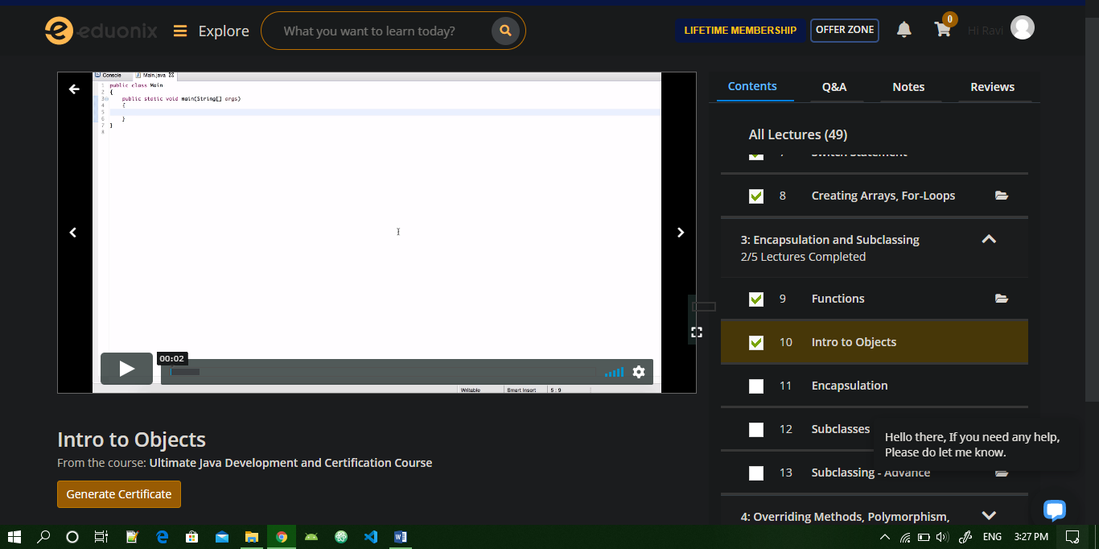

Coding Challenges Details:

/* multithreaded program using subclassing Thread */

class ThreadA extends Thread{

public void run( ) {

for(int i = 1; i <= 5; i++) {

System.out.println("From Thread A with i = "+ -1*i);

}

System.out.println("Exiting from Thread A ...");

}

}

class ThreadB extends Thread{

public void run( ) {

for(int j = 1; j <= 5; j++) {

System.out.println("From Thread B with j = "+ 2*j);

}

System.out.println("Exiting from Thread B ...");

}

}

class ThreadC extends Thread{

public void run( ) {

for(int k = 1; k <= 5; k++) {

System.out.println("From Thread C with k = "+ (2*k-1));

}

System.out.println("Exiting from Thread C ...");

}

}

class MultiThreadClass{

public static void main(String args[]) {

ThreadA a = new ThreadA();

ThreadB b = new ThreadB();

ThreadC c = new ThreadC();

a.start();

b.start();

c.start();

System.out.println("... Multithreading is over ");

}

}